GOGG Resource List 2024
(Also available in DE Letter to schools 04/11/2024)
PE through Irish

COGG recently published exciting new resources to facilitate the delivery of strands of PE through Irish for Junior and Senior Infants. These resources will be built on over the coming years for all stages at primary level. Corpoideachas trí Ghaeilge

COGG have also recently published resources for schools to support the teaching and learning of Irish for students with Special Educational Needs. An Tairseach (Please choose ‘’Oideachas Speisialta’ from the drop-down menu)

COGG have provided a list of suitable Irish resources which are below at Appendix 1.

Gaelbhratach. About - Gaelbhratach
Gael Linn oversee the Gaelbhratach scheme which aims to create natural opportunities to speak Irish outside the of classroom and Irish lesson time. The scheme is available to all schools, primary and post primary, in all areas of the country.

Conradh na Gaeilge’s School Year Planner including Gaeilge24.
School Year Planner 23/24 - Conradh na Gaeilge | Ar son phobal na Gaeilge (cnag.ie)
Conradh na Gaeilge has a list of Irish language events/Services available to schools to assist teachers in raising awareness about the Irish language throughout the school year, including Seachtain na Gaeilge and Gaeilge24, the aim of this challenge is to encourage young people to try speak Irish non-stop for one whole day, 24 hours: at home, at school, in shops and businesses, around the town, in sports clubs and with friends.
Gaeilge24 - Conradh na Gaeilge | Ar son phobal na Gaeilge (cnag.ie)
Irish language online media:
- Nuacht Cúla4 (cula4.com)
- Home School Hub: All the Irish lessons in one place! (rte.ie)
- Foghlaimeoirí – Tuairisc.ie
- Nosmag.com
- Podcasts - Podchraoltaí - Raidió Rí-Rá (rrr.ie)

Áis | Cur síos/Description | Le fáil ó/Available from
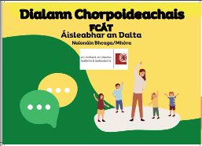  Corpoideachas trí Ghaeilge | - A new resource to help teachers to integrate the teaching of Irish with the Athletics strand in PE.  - Through the use of this resource, children will learn Irish in an fun, exciting and natural way.  - Resources are currently available for the Infant classes and additional resources will be developed for 1st to 6th classes as the children progress through the school. | Register for resources here:  https://www.cogg.ie/corpoideachas-tri-ghaeilge/
Taisce Tuisceana  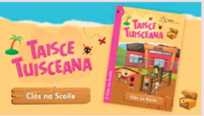 | - A graded reading comprehension resource, covering a wide range of reading genres  - 5 boxes (A, B, C, D, E), each containing a series of 25 cards with a wide range of reading comprehension materials, both fiction and non-fiction, as well as types of texts such as poems, stories, diaries, e-mails and reports  - The texts become progressively more challenging, beginning with Bosca A which is suitable for children in 2nd class. | Available to buy from:  www.siopaudar.ie  €30 per box  A digital downloadable version is available from https://tairseachcogg.ie  Further support material and videos available from:  Taisce Tuisceana | CCEA
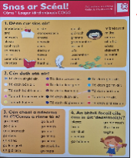  Snas ar Scéal | - A useful resource which will help children to develop their oral language and writing skills.  - 2 cards containing word lists and expressions that are often needed by children as they engage in oral language and writing.  - Cárta 1 is suitable for children from 1st class | Available to buy from:  www.siopaudar.ie  €15 per pack of 10 cards  A digital downloadable version is available from https://tairseachcogg.ie
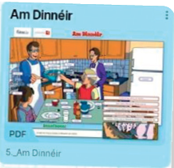  50 Póstaer- Foinse/COGG | - A set of 50 colourful posters based on the themes in Curaclam Teanga na Bunscoile.  - Includes at least four posters relating to each theme, eg. Lá Fhéile Pádraig, Turas Scoile, Oíche Shamhna agus An Nollaig relate to the theme Ócáidí Speisialta | Available free  Email: eolas@cogg.ie  A digital downloadable version is available from https://tairseachcogg.ie
Turas na Scríbhneoireachta  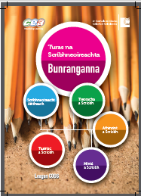 | - This manual provides guidance on how schools may approach the teaching of a number of writing genres. Appropriate assessment tools are suggested, along with a variety of practical activities.  - There are two manuals available, a manual for Bunranganna and another for Ardranganna.  - Teachers are recommended to choose activities according to the abilities and needs of the children. | Available to buy from:  www.siopaudar.ie  €15 per manual  A digital downloadable version is available from https://tairseachcogg.ie
Spreag an Ghaeilge le Spraoi  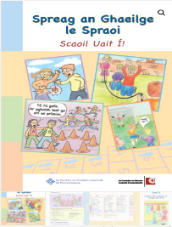 | A useful resource to help teachers promote and develop the use of Gaeilge throughout the school day.  - Includes lesson plans, language games and yard games.  - Teachers are recommended to choose activities according to the abilities and needs of the children. | Available to buy from:  www.siopaudar.ie  www.siopaleabhar.com  www.anceathrupoioi.com  www.siopagaeilge.ie  €25  A digital downloadable version is available from https://tairseachcogg.ie
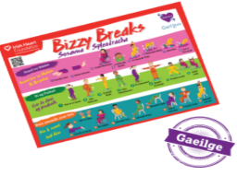 | - Bring movement and Irish together with Bizzy Breaks as Gaeilge (Sosanna Spleodracha).  - Classroom resources available including support handbook, video and posters  - Suitable for all classes. | Online resources available here:  https://irishheart.ie/schools/primary-schools/bizzy-breaks/bizzy-as-gaeilge-sosanna-spleodracha/
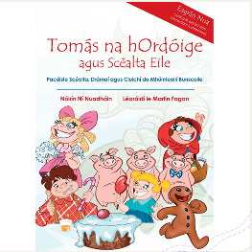  Tomás na hOrdóige | - An interactive package of stories, plays and games for Primary School Teachers to support teaching Irish in the classroom  - 6 laminated A4 pictures with each story  - Short simple play script with each story  - Patterns to make masks and hand and finger puppets  - Suitable for all classes from the junior classes upwards | Available to buy from:  https://cic.ie/shop/books/ar-maidin-moch-eagran-nua-2024/?lang=en  Access the laminated A4 pictures here:  Tomás na hOrdóige (new edition)
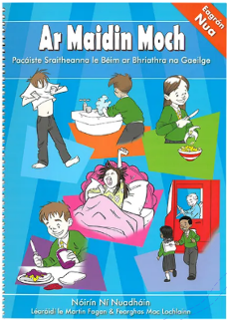  Ar Maidin Moch | - An interactive package based on the daily activities of children, eg. getting up, breakfast, the school day, sports training etc. to support teaching Irish in the classroom.  - There are ten series in the book with six illustrations with each one, vocabulary learning activities, language games, role play, recipes for a healthy breakfast or lunch, intercultural discussion, verb tenses and grammar notes.  - Suitable for all classes from Junior Infants upwards | Available to buy from:  https://cic.ie/shop/books/ar-maidin-moch-eagran-nua-2024/?lang=en  Access the 10 series of pictures here:  https://tairseachcogg.ie
Séideán Sí  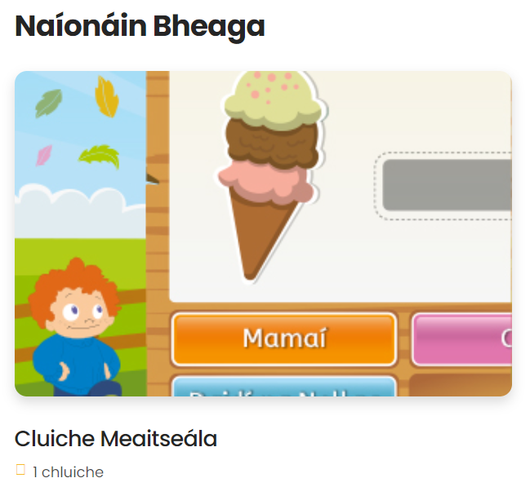 | - A range of digital resources and activities are available which are based on what is already available in the printed program.  - Printed materials, including big books, and leabhairíní, are also available  - Teachers are recommended to choose activities according to the abilities and needs of the children. | www.seideansi.ie  View the catalogue of resources here:  https://seideansi.ie/dep/files/catalogue_2022.pdf  https://seideansi.ie/dep/files/s_si_leabhairini_urscealta_ranga.pdf
Digital resources  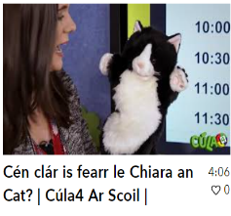  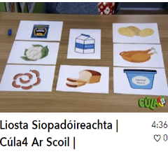 | - Useful links to support the teaching and learning in the early years and in Primary School  - Teachers are recommended to choose activities according to the abilities and needs of the children. | https://padlet.com/maire8/rannta-d-nta-amhr-in-do-ph-ist-ga-dkq9f7jlawlksvhs  https://padlet.com/maire8  https://foghlaim.tg4.ie/bunscoil/rannta_agus_amhrain  https://foghlaim.tg4.ie/bunscoil/gaeilge  https://foghlaim.tg4.ie/bunscoil/gaeilge/164
Nuacht Anois  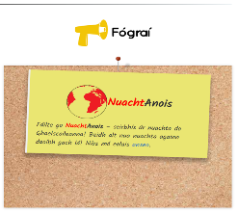 | - A new digital resource for schools  - A new article each day that references current stories in the news or topics relevant to the curriculum.  - Teachers are recommended to choose activities according to the abilities and needs of the children. | Available free from:  https://www.leighanois.com/nuacht
Cluichí do Pháistí | - Games to support children learning Irish, eg. Snap as Gaeilge, Junior Scrabble, Os mo Chionn, Jigsaws and puzzles  - Teachers are recommended to choose activities according to the abilities and needs of the children. | Available to buy from:  https://www.siopaudar.ie/2024/08/08/na-tairgi-is-fearr-don-seomra-ranga-bunscoile/
Leabhair do Pháistí | - Irish books for children including picture books and novels  - Picture books available for all ages | Available to buy from:  www.angum.ie  www.siopaleabhar.com  www.siopaudar.ie  www.siopagaeilge.ie  www.cic.ie  www.litriocht.ie  www.siopa.ie

