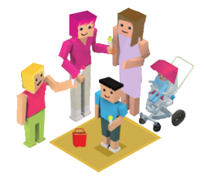

Different Families, Same Love Entry Form

This form along with your entry should be submitted to differentfamiliessamelovecomp@gmail.com by **5pm, May 23rd 2025.**

**Category (Tick one)**

O Junior Infants - 2nd Class / P1 – P4 O 3rd Class - 6th Class / P5 – P7 O Whole school

School Name: _____________________________________________

Address: _________________________________________________

________________________________________________________

________________________________________________________

Is your school a special school? Yes No Teacher: ____________________________

Class: _____________________________ Contact Number: _____________________

Email: __________________________________________________________________



Describe your entry (how you explored the topic, what you did, how you shared your learning with others etc).

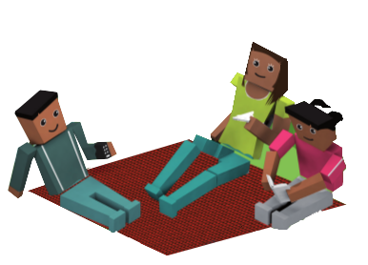

Would you recommend the ‘Different Families, Same Love’ Competition to other teachers? If yes, why? If no, please suggest how it can be improved.

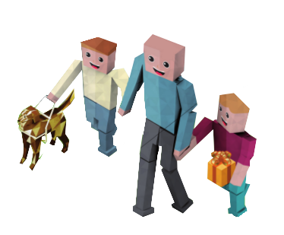

**Terms and Conditions**

* The INTO LGBT+ Teachers’ Group cannot accept responsibility for lost, damaged or delayed entries.
* Projects must be the pupils’ original work.
* The judges and organisation will not enter into correspondence with regard to judges’ decisions, and the decision of the judges for all competition entries will be final.
* No cash or alternative in whole or part of the prize will be offered.
* By submitting an entry, entrants consent for photos and/or footage of their projects to be used for promotional purposes.
* Each entry form must have the signature of a teacher/principal to attest it is the pupils’ own work and has the support of the school.
* Projects may be completed in Irish or English.
* Entries must be submitted to differentfamiliessamelovecomp@gmail.com by **5pm on May 23rd 2025. Video entries must be 3 minutes or less.**
* Schools may submit multiple projects.
  + Projects that are three dimensional can be submitted as photographs. Projects can be submitted by an online link or using a cloud sharing platform (e.g Dropbox, Google Drive, Wesend etc).

I have read and agree to the terms and conditions of this competition

Teacher Signature: Date: